Git Workflow - GitHub Desktop Workflow

Open GitHub Desktop
# Source: ScreenShots Source: Provided by: [Persons Table -> ID Column: 1, Name_En Column: Motasem Essam] -> Tool: [Lightshot Program] -> From [Site: https://github.com] on [2/17/2026]
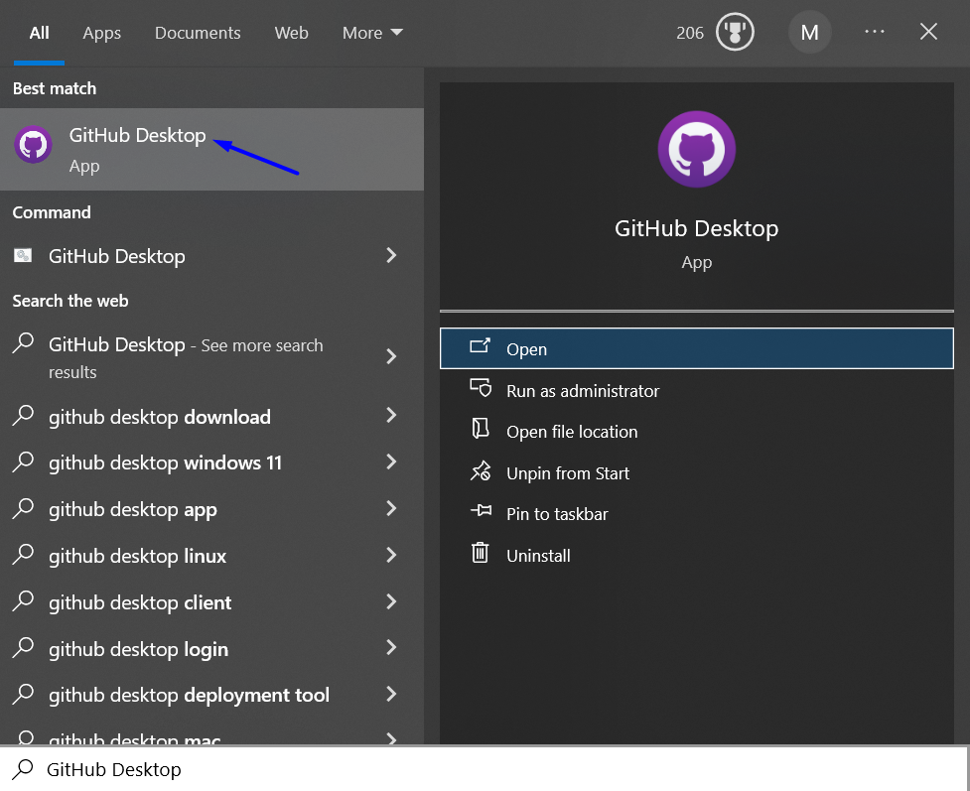

Log in
# Source: ScreenShots Source: Provided by: [Persons Table -> ID Column: 1, Name_En Column: Motasem Essam] -> Tool: [Lightshot Program] -> From [Site: https://github.com] on [2/17/2026]
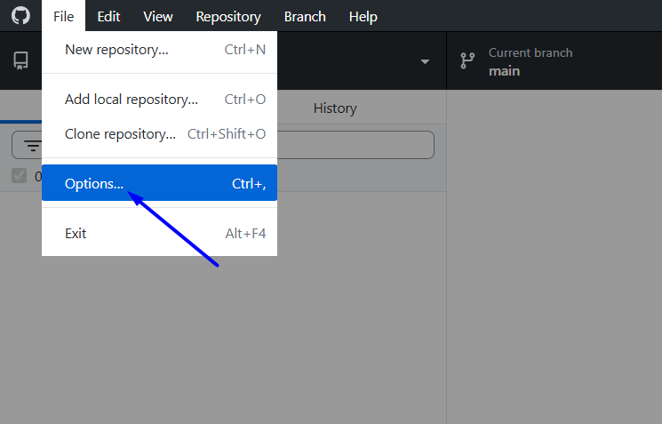
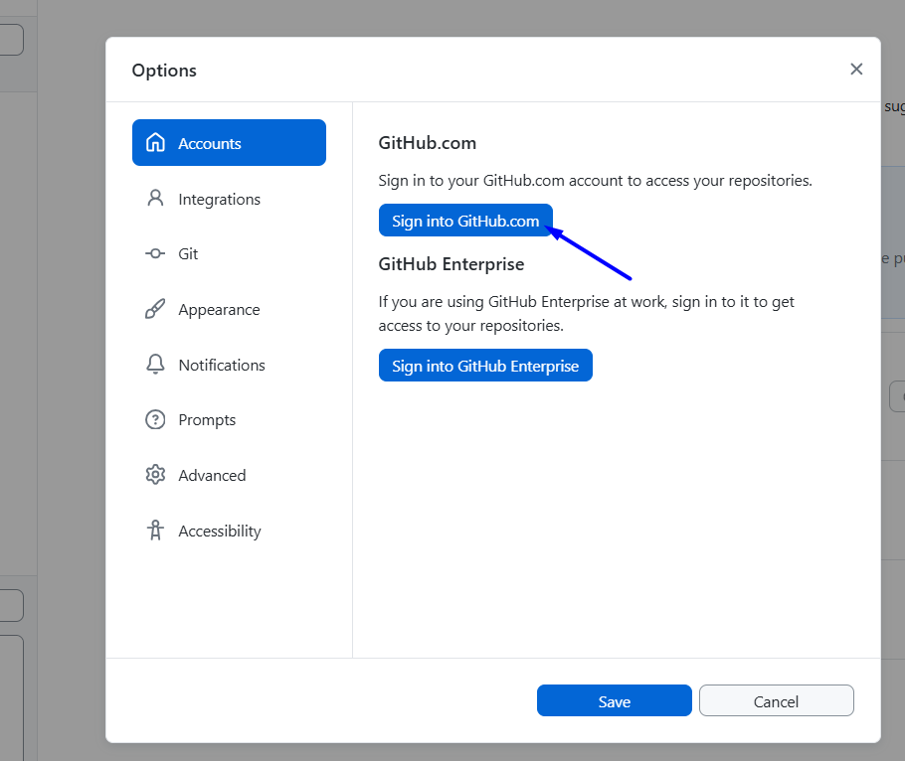
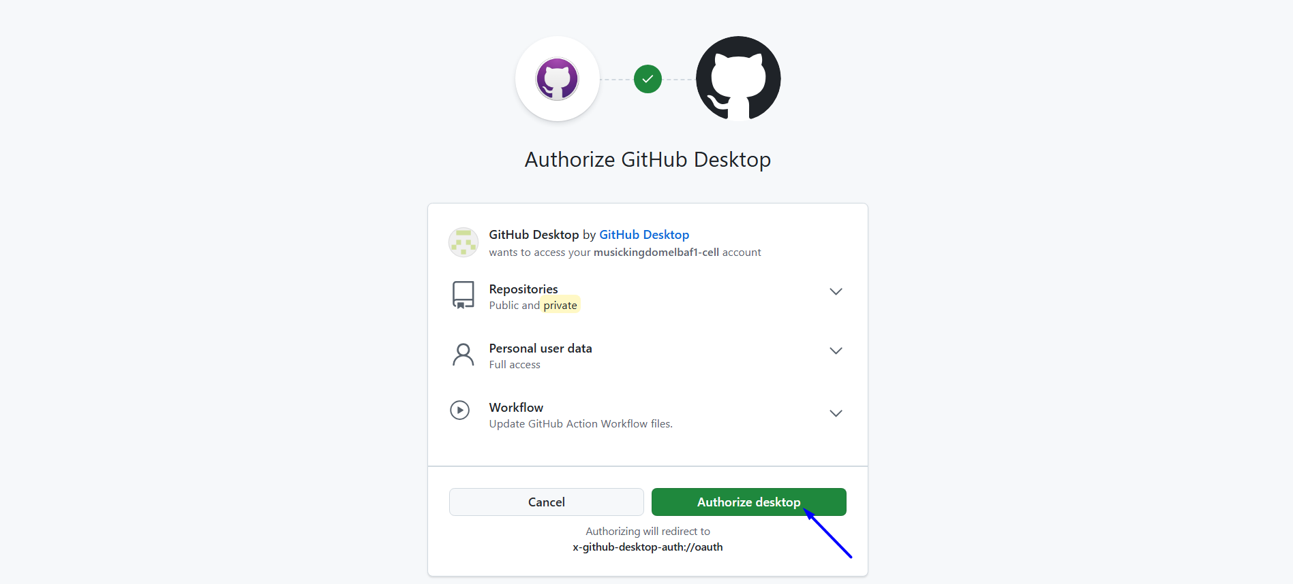
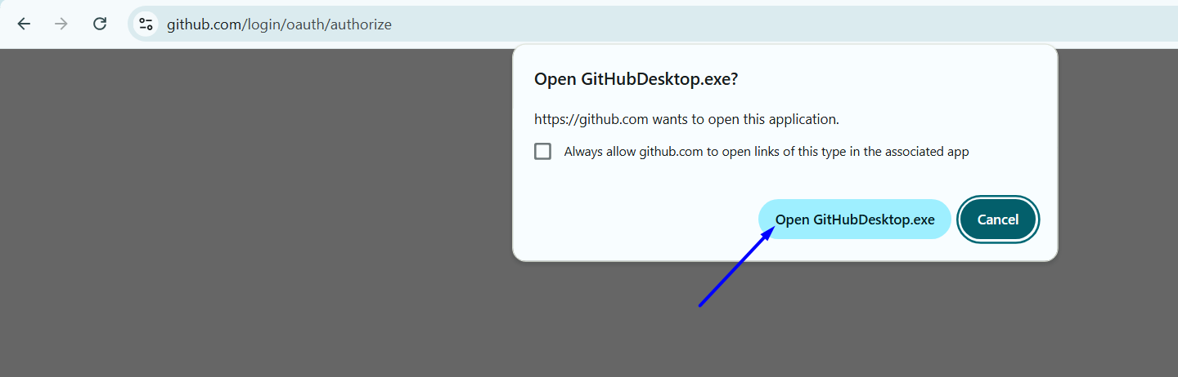

Add local repository
# Source: ScreenShots Source: Provided by: [Persons Table -> ID Column: 1, Name_En Column: Motasem Essam] -> Tool: [Lightshot Program] -> From [Site: https://github.com] on [2/17/2026]

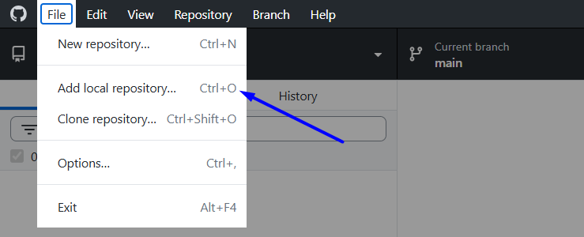
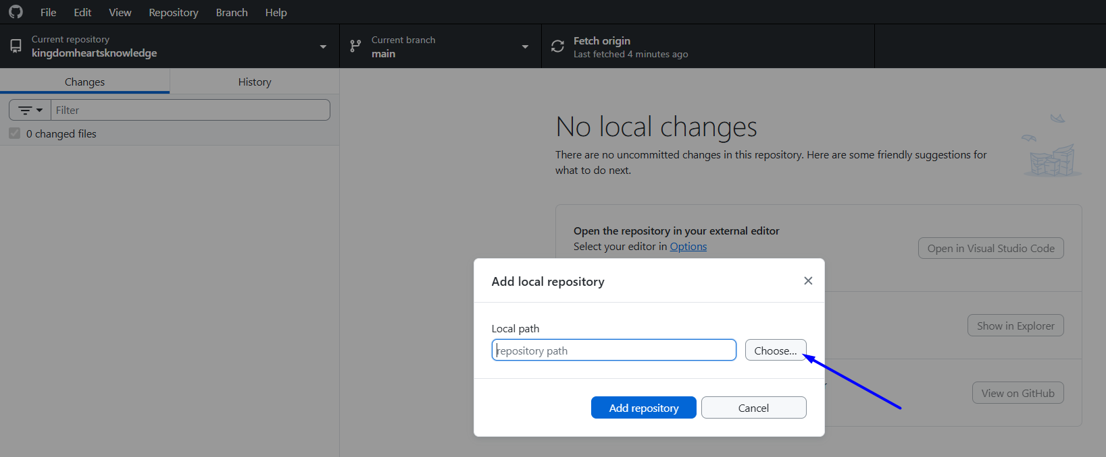
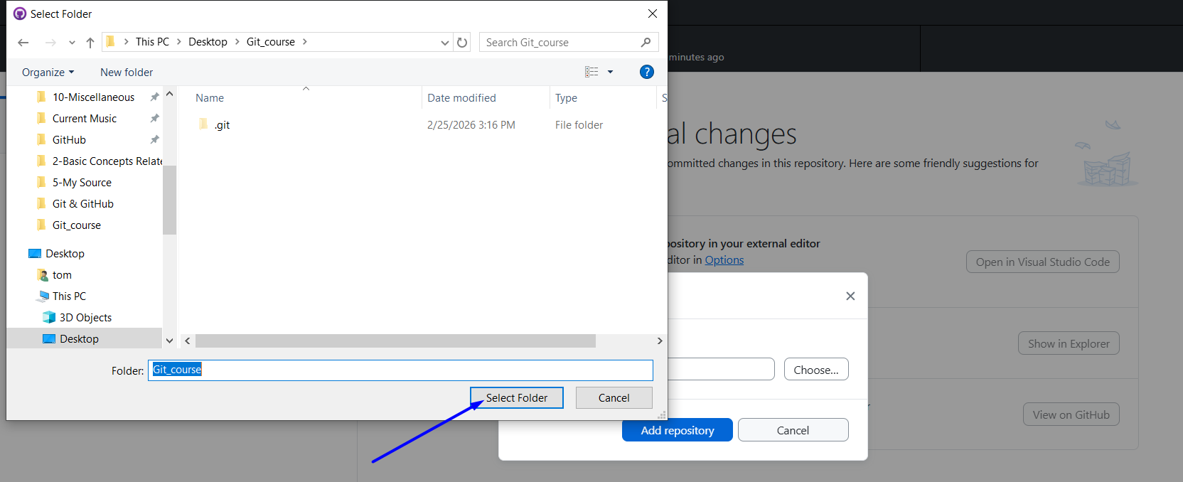
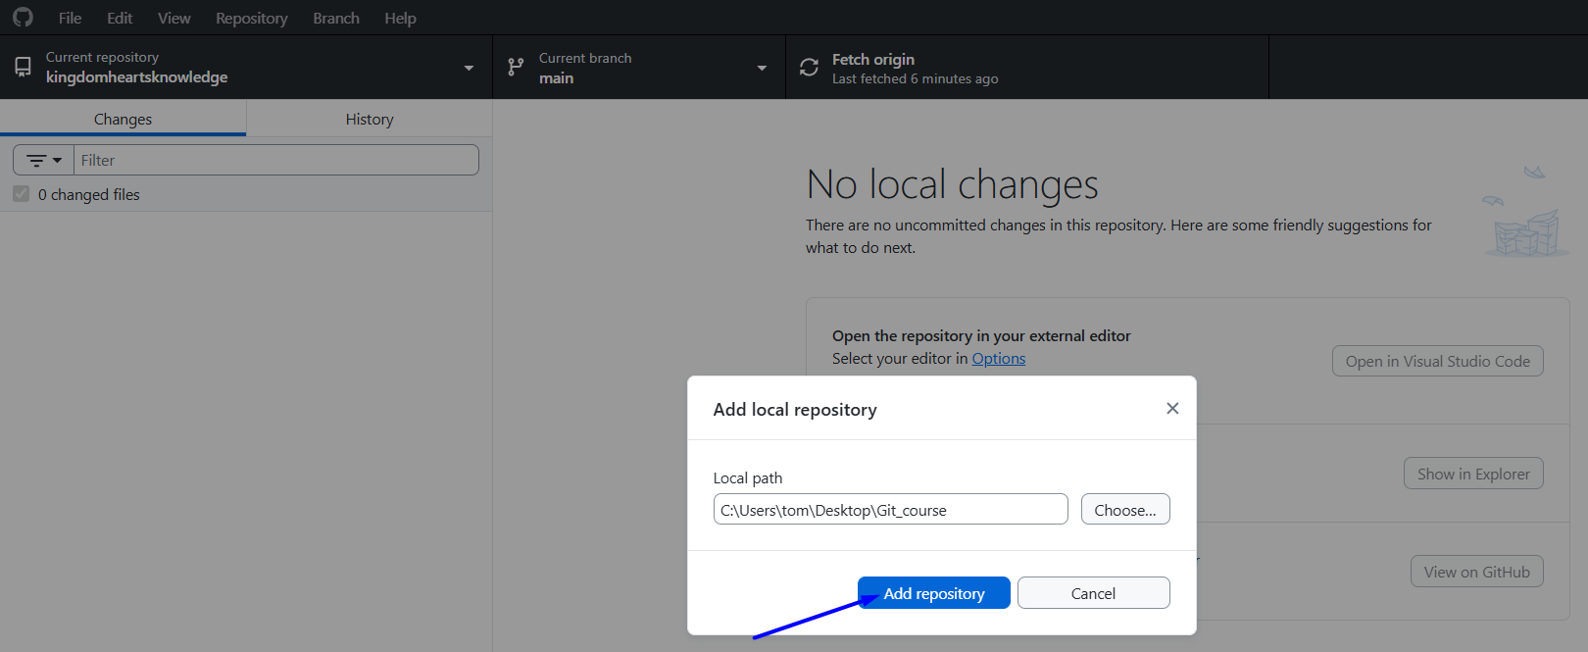
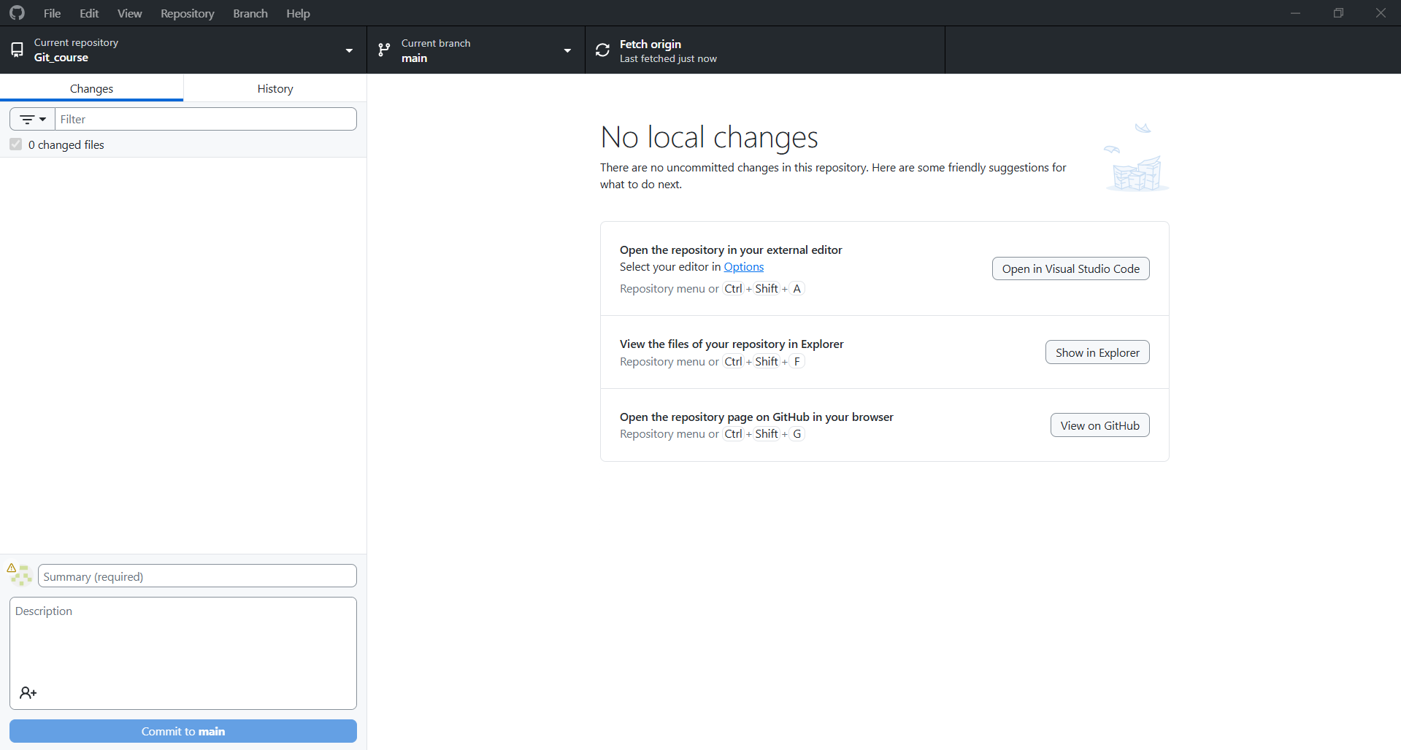

From staging to Workspace to Local repository
# Source: ScreenShots Source: Provided by: [Persons Table -> ID Column: 1, Name_En Column: Motasem Essam] -> Tool: [Lightshot Program] -> From [Site: https://github.com] on [2/17/2026]
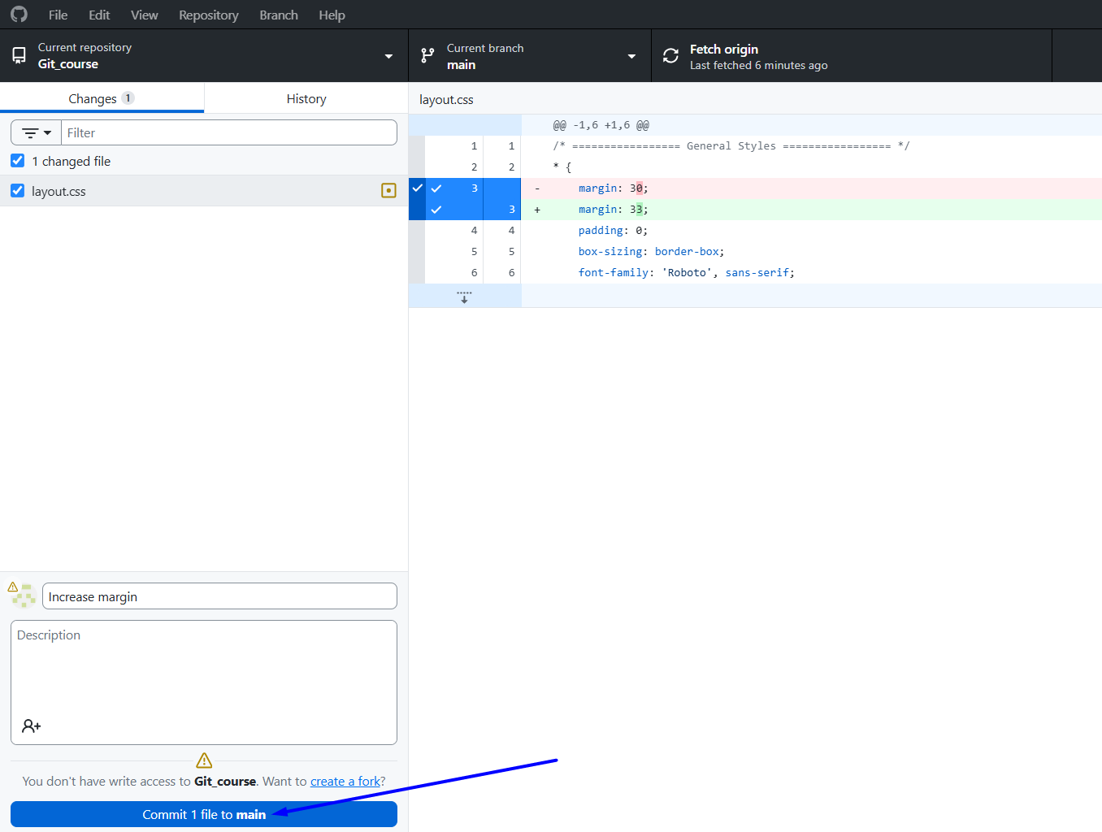

From Local repository to Remote repository
# Source: ScreenShots Source: Provided by: [Persons Table -> ID Column: 1, Name_En Column: Motasem Essam] -> Tool: [Lightshot Program] -> From [Site: https://github.com] on [2/17/2026]
